

ROCK PAPER SCISSOR GAME

Submitted to-sagar pande

Submiited by-

* Ritanshu shivhare
* 11910220
* 56

Date-30/10/2020

ABSTRACT

The project resulted in the formation of ROCK PAPER SCISSOR which is tell about present day and wishing you good morning and good afternoon according to which time you run the code.This game is applicable to speak with help of pyttsx3 and speech reconigation many other module…

ACKNOWLEDGEMENT

I would like to express my special thanks of gratitude to our facilty **MR.SAGAR PANDE** who gaves me such golden opportunity to do this wonderfull insight project on the topic of ROCK PAPER SCISSOR.Which is also help to understood or improve my pyhton skills. In this project I has learned very new things like using of speech recongnition and speak function or datetime function.I got to know so many clear idea of the fact in how many we can use python language.

CONTENTS

1. Tell about present day
2. Wishing you good morning and noon according to when you run the program
3. Program speaks about rules of the game
4. Uses of graphics user interface
5. Uses of speech recongnition
6. Uses of pyttsx3

INTRODUCTION

We made this project using purely pyhton language where I used gui through tkinter library,we used other libraries to add more functionality to our project like random or pyttsx3 and datetime or specch recongontion.we used speak function whicg speaks and tells about rules of the game.using all these concepts of pyhton language we successfully

Made this wonderfull game called ROCK PAPER SCISSORS……

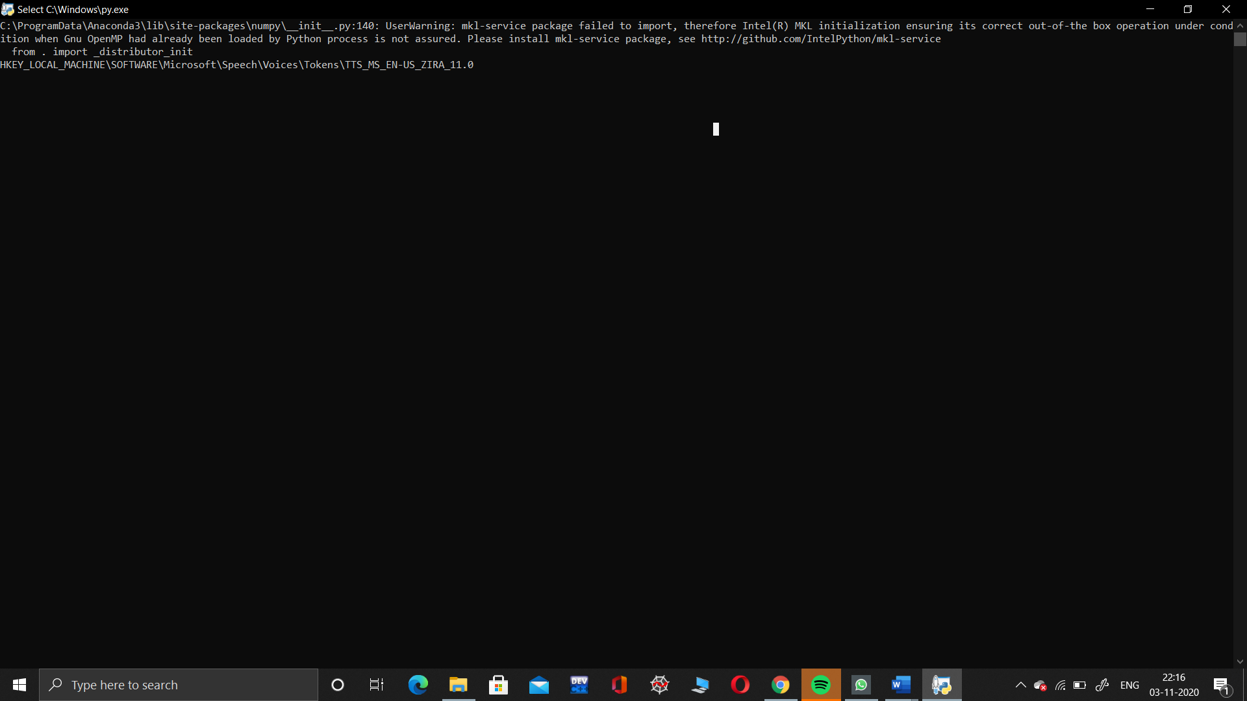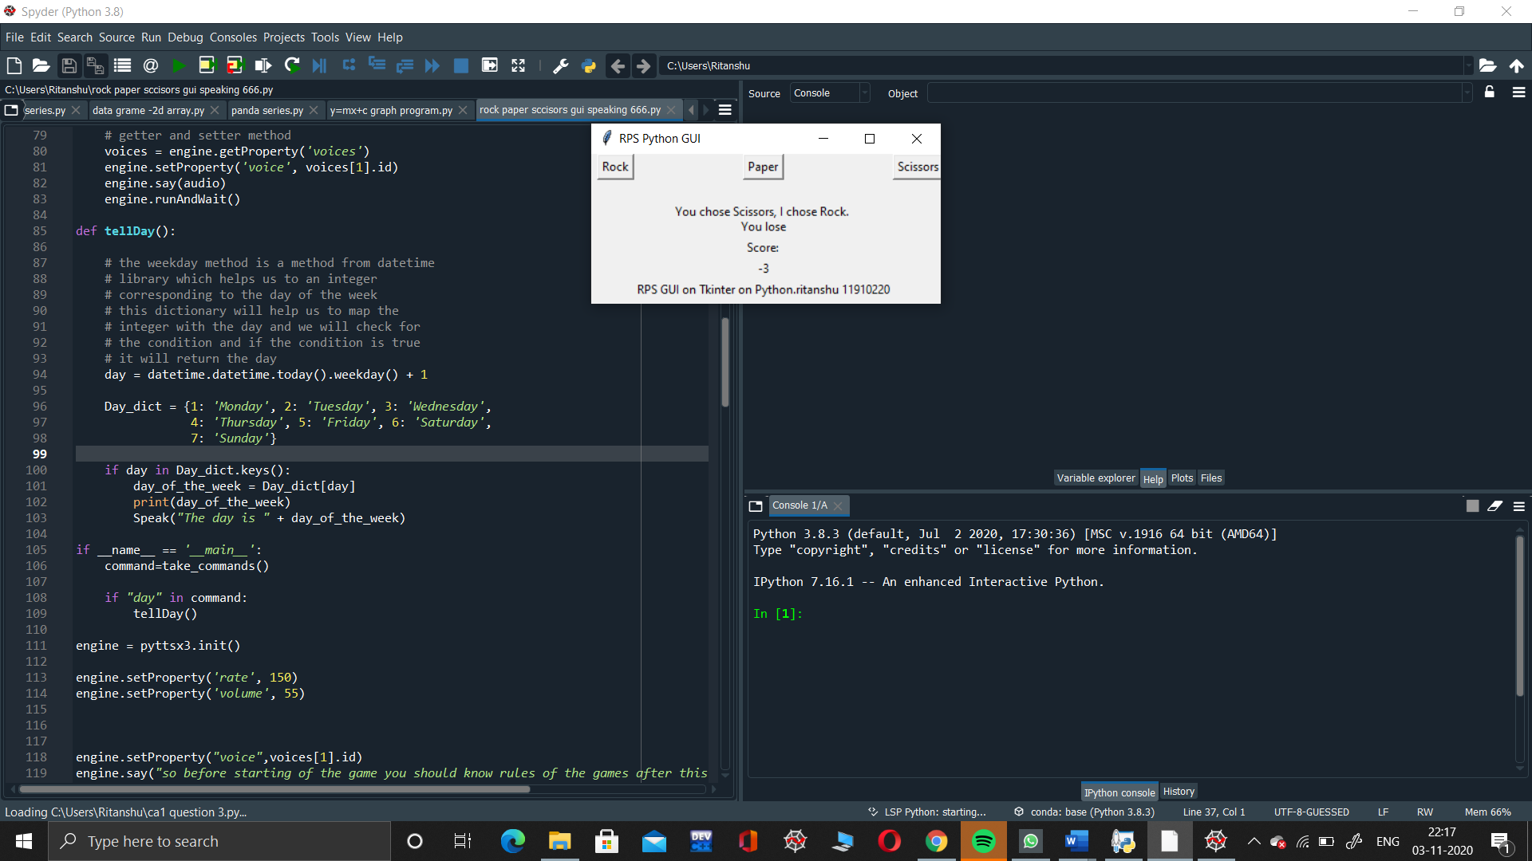

Reference

* <https://www.w3schools.com/python/python_gui_programming.htm>
* <https://docs.python.org/3/tutorial/>
* <https://www.geeksforgeeks.org/python-gui-tkinter/#:~:text=Python%20offers%20multiple%20options%20for,to%20create%20the%20GUI%20applications>
* [www.youtube.com](http://www.youtube.com)